Practice Problems Section 12 Solutions

1. An inductor ( $L=$ 54 mH), resistor ( $R=$ 27 Ω) and a DC battery ( $ε=$ 9.0 V) are connected in series. At $t=0$, a switch is closed, completing the circuit.
2. Draw a graph of the current in the circuit as a function of time. Make sure to mark the following on the graph: The numerical value of the maximum current on the current axis and the numerical value of the time constant $τ$ on the time axis, as well as the value of the current at this time. **Show your work!**

The inductor produces a back emf, which stops the current from rising to its maximum value instantaneously. Thus, the current starts initially at $i(0)=0$, and then grows to its maximum current. The current growth obeys the function

$$i\left(t\right)=I_{max}\left(1-{e^{-}}^{\left(R/L\right)t}\right)$$

The maximum current can be found by noting that as $t→∞$, the current stops changing, and thus the inductor stops producing a back emf. At this time, the voltage across the inductor is zero, and so the circuit acts as though it were simply a battery and a resistor. Thus, $I_{max}=\frac{ε}{R}=\frac{9}{27}=.33 \text{A}$.

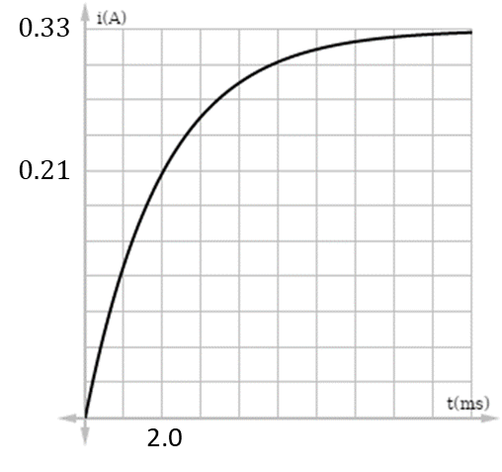The time constant $τ=\frac{L}{R}=\frac{.054}{27}=2.0\text{ ms}$, is the time at which the exponential factor in the expression becomes $e^{-1}$.

From the function, you can see that when $t=τ, i\left(τ\right)=I_{max}\left(1-e^{-1}\right)≈.21\text{ A}$.

All together then, the graph looks as it does to the right.

1. How much energy is stored in the inductor at the time $t=τ$? **Show your work**.

The energy stored in the inductor (equivalently in the magnetic field) is given by $U_{L}=\frac{1}{2}Li^{2}$. Thus, at time $t=τ$, the energy is

$$U_{L}\left(τ\right)=\frac{1}{2}Li{\left(τ\right)}^{2}=\frac{1}{2}\left(.054\right){\left(.21\right)}^{2}=1.2 \text{mJ}$$

1. An inductor ( $L=$ 19.8 mH) is connected in series to a capacitor ($C=19.6 \text{mF})$. Assume negligible resistance. At some moment, the energy stored in the magnetic field is equal to the energy stored in the electric field. The energy in each is 17.5 mJ.
2. What is the maximum charge stored by the capacitor in this system?

In an LC circuit with no resistance, energy is conserved, constantly transferred between the magnetic and electric fields (equivalently between the inductor and capacitor). Based on the problem,

$$E_{tot}=U_{C}+U_{L}=17.5 \text{mJ}+17.5 \text{mJ}=35.0 \text{mJ}$$

This total energy can never change. In particular, the maximum charge occurs when all of the energy is stored on the capacitor. Thus the maximum charge must be such that $U_{C,max}=35.0\text{ mJ}$. Thus,

$$U_{C,max}=\frac{1}{2}\frac{Q_{max}^{2}}{C}→Q_{max}=\sqrt{{2CU}_{C,max}}=.037 \text{C}$$

1. What is the maximum current in the circuit?

Similarly, the maximum current occurs when all the energy is stored in the inductor. Thus the maximum current must be such that $U_{L,max}=35.0\text{ mJ}$. Thus,

$$U_{L,max}=\frac{1}{2}LI_{max}^{2}→I_{max}=\sqrt{{2U}_{L,max}/L}=1.88\text{ A}$$

1. Assume that at $t=0$, the capacitor was fully charged. Write an expression for the charge stored on the capacitor as a function of time.

The general expression for the charge on the capacitor is $q\left(t\right)=Q_{max}\cos\left(ωt+φ\right)$. In this case, since the capacitor is fully charged at $t=0$ s, $φ=0$. We also know that $Q_{max}=0.037 \text{C}$. The angular frequency $ω=\sqrt{\frac{1}{LC}}=50.8$ rad/s. Thus,

$$q\left(t\right)=\left(0.037 \text{C}\right)\cos\left[\left(50.8 \text{rad/s}\right)t\right]$$

This function would allow you to predict the charge on the capacitor at any time.

1. Write an expression for the current in the circuit as a function of time.

The current in the circuit is equal to the rate of change of the charge on the capacitor. Thus,

$$i\left(t\right)={dq(t)}/{dt}=-\left(.037 \text{C}\right)\left(50.8 \text{rad/s}\right)\sin\left[\left(50.8 \text{rad/s}\right)t\right]$$

$$→i(t)=-(1.88 \text{A})\sin\left[\left(50.8 \text{rad/s}\right)t\right]$$

Note that the maximum value the current can take (when the sine function is equal to -1), is indeed equal to the maximum current found in part b)!

$v_{C}=\frac{q\left(t\right)}{C}$ $v_{L}=-L\frac{di(t)}{dt}$ $U_{L}=\frac{1}{2}Li^{2}$ $U_{C}=\frac{1}{2}\frac{q^{2}}{C}$

LC Circuits: $q\left(t\right)=Q_{max}\cos\left(ωt+φ\right)$ $i\left(t\right)=\frac{dq\left(t\right)}{dt}$ $ω≡2πf≡\frac{2π}{T}=\sqrt{\frac{1}{LC}}$

LR Current Growth: $i\left(t\right)=I_{max}\left(1-e^{-\left(R/L\right)t}\right)$ LR Current Decay: $i\left(t\right)=I_{0}e^{-\left(R/L\right)t}$